***Answer the following questions***

***From: Curriculum #1 - Introduction to SAP HANA (total 20 Points)***

*01_Introduction_to_ SAP HANA_Chapter_2_Reporting_Exercise* ***(5 Points)***

* What are the „Top 5 US Customers in 2011“?
  + **Beantown Bikes**
  + **Big Apple Bikes**
  + **Rocky Moutain Bikes**
  + **Northwest Bikes**
  + **DC Bikes**
* Attach the pdf document “Compare U.S. customer annual revenues over time”(**Attached**)

*From “03_Introduction_to_SAP_HANA_Chapter_3_Data_Modeling_Exercise”****(4 Points)***

* What is the data type and length of field *COUNTRY*?

**Data type is NVARCHAR and length of field is 2**

* Is the table of type *Column Store* or *Row Store*?
* **Column Store**
* To which sales organization does the customer Motown Bikes from Denver belongs to?
* **Invalid. Customer Motown Bikes is from City Detroit (NOT Denver), and Motown Bike belongs to Sales Organization – UE00**
* What is the name of the database tables used in this view?
* **GBI_DEMO_PRODUCT**

*From “06_Introduction_to_SAP_HANA_Chapter_5_Case_Study”* ***(7 Points)***

You create all database tables in the database schema GBI_###, whereas ### stand for your individual ID. Please take care you use your own ID!

*The following HANA artefacts are required in the HANA catalog*

* *CUSTOMER_ATTR_###.hdbtable*
* *PRODUCT_ATTR_###.hdbtable*
* *SALES_###.hdbtable*

Fill in the provided data in the 3 HANA DB-tables.

*In your package* *gbi-student-###, create the flowgraph model*

* *CustomerFlow*.

*In your package* *gbi-student-###,* *create a calculation view for the customer data*

* *CUSTOMER_DIM_CV_###*
* **Run** the calculation view to check the contents.

Create a calculation view for product data

* *PRODUCT_DIM_CV_###*
* **Run** the calculation view to check the contents

Create a calculation view for your sales data

* *SALES_CUBE_CV_###*
* **Run** the calculation view to check the contents

Analyze the sales data ***(4 Points)***

* What is the total revenue in Germany in May 2011?
* **The total revenue in Germany in May 2011 was 4,887,410.42.**

What are the top 3 products by revenue sold in Germany in May 2011?

1. **Product: RACA1110, Product Name: Road Bike Carbon Shimano**
2. **Product: PRTR2100, Product Name: Professional Touring Bike-Silver**

**3. Product: ORMN1100, Product Name: Men’s Off Road Bike Fully**

**From Curriculum #2 - Native Development (total 20 Points)**

*From “06_Native_Development_Chapter_02_OData_in_SAP_HANA_Case_Study_en”****(3 Points)***

* In your package *gbi-student-###* create a new package under it with the name *UI5App*.
* Create a new package *models* under the package *UI5App*.
* build our OData service *GBI.xsodata* and enter the required coding which generates an OData Service
* As you can see an OData “service” uses the “Atom” format and is build out of a “workspace” with a “title” and one or many “collections” also with a “title”
* The <service> tag defines particular OData Services. It defines starting point for service consumption
* <workspace> tag contains a list of all server-side resources that are available for manipulation
* <collection> tag identifies an individual server-side resource
* 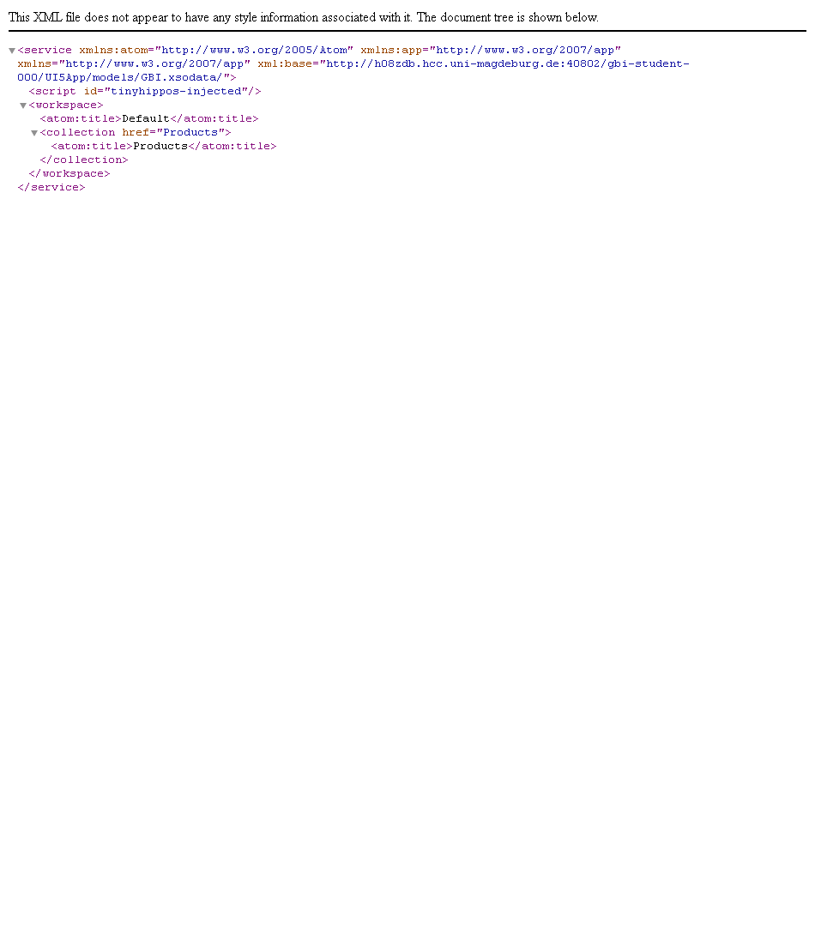

With which URL can you read all products in the (list) collection?

Your answer: [**https://h13-d01.ucc.ovgu.de/gbi-student-040/UI5App/models/GBI.xsodata/Products**](https://h13-d01.ucc.ovgu.de/gbi-student-040/UI5App/models/GBI.xsodata/Products)

*From 08_Native_Development_Chapter_01_SAPUI5_Exercise_#1_en* ***(4 Points)***

Create a new package with the name *HelloWorld* under the package *gbi-student-###*

And create the three files:

* *index.html*

*what two types of code does it contain?*

1. ***HTML for the basic definition of the website***

***b) JavaScript for the definition and handling of controls.***

*From 10_Native_Development_Chapter_03_SAPUI5_Exercise_#2_en* ***(5 Points)***

create a new package with the name *MVCHelloWorld* under the package *gbi-student-###*

in the package *MVCHelloWorld* that will hold all of the controllers and views create **New ► Package**and

* create a new package *content* and here create a new file *Main.view.xml*
* create the file *Main.controller.js* in the package *content*
* *if implemented properly you should now* see the label “Hello World” on a webpage, and if clicked the text should change to “Clicked!”.

*From 11_Native_Development_Chapter_03_SAPUI5_Case_Study_en* ***(8 Points)***

In the package **UI5App**,

* create a new package with the name “*content”* and
* in here create a new file *Main.view.xml*
* create the file *Main.controller.js* in the package *content*.
* As in the next step the existing *index.html* file is overwritten, you can rename the old index file in e.g. *index_1.html* file and create a new *index.html* file.
* After implementation a “hello MVC!” text should appear in the browser.
* You can now also rename the existing Main.view.xml file and create a new one.

Create the files in the package *content*

* *Overview.view.xml* and
* *Overview.controller.js*.

When you open your application you should see the new navigation items “Overview” and “Sales Orders” plus the labels of the pages (see page 18/19). At the end the user of your application should see data coming from our OData Services.

Get the coding ready to display in the “Sales Order” View the GBI data plus the Contact Data.